**LAB 6 - Part 1**

Create this Karplus Strong string modeling synthesizer using the file “Lab6 - Part 1 - DEMO.maxpat”. Take note that the patch and video breaks down the building process into several steps, but the image below is what your final patch should look like.

**Due: turn in a screenshot of your finished patch and name it as follows: “lastname firstname lab 6 part 1”. Please also include a comment with your name in the patch.**

Lab 6 Part 1 Video link:

Follow the video demonstration and the extensive comments within the patch to guide you to make the patch pictured below.

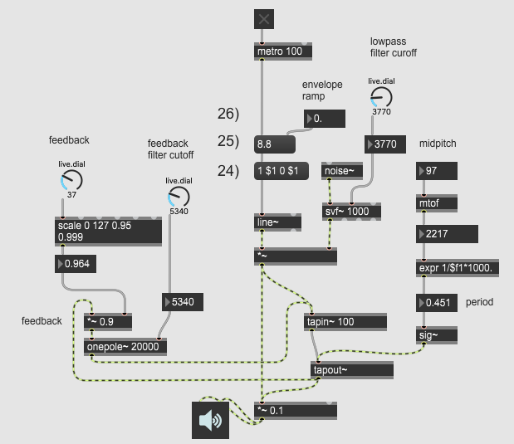

**LAB 6 - Part 2**

**Due: Answer the questions below and turn in the answers in a document labeled as follows : “lastname firstname lab 6 part 2”. Please save your document as a pdf.**

1. Explore the Karplus Strong string synthesizer by trying out different values for the variable parameters in the patch: feedback, feedback filter cutoff, envelope ramp, low pass filter cutoff.
   1. Describe the effect that each parameter has on the timbre of the resulting sound
   2. Write down a set of values for each parameter that is appropriate to make a sound that sounds good to you
2. Why does the feedback parameter have to be a number less than 1? What would happen if the feedback parameter was a number greater than or equal to 1?
3. Notice that noise~ is being fed into an svf~ object or “state variable filter”. Right now, we’re using svf~’s left outlet. Experiment by connecting the different outlets to *~ and describe how they change the sound. Click on svf~ and press ctrl/cmd + shift + h to open the help file if you need a hint.